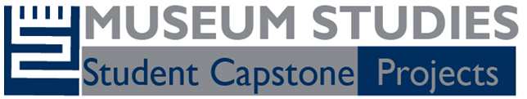

Museum Studies Proseminar Presentations of Capstone Projects

Please join us for the presentations of this year’s capstone projects for students enrolled in the museum studies proseminar.

Monday, April 11
Deaccessioning Out Loud at UMMA
Katelin Mikos, Emily Na, Chuyi Zhu

Forward Motion: Expanding the Educational Breadth of the Ford Piquette Avenue Plant
Leila Braun, Sony Prosper, Estrella Salgado, Taylor West

Wednesday, April 13
Realigning the Rails: The Opportunities of Reopening at the Southern Michigan Railroad Society
Melissa Gryan, Chad Machinski, Gala Patenkovic

Marking Time: Reimagining Detroit’s Historical Markers
Bailey Franzoi, Mona Hagmagid, Pelle Tracey

These student capstone projects were hosted by the Ford Piquette Avenue Plant Museum, the Michigan Historical Commission, the Southern Michigan Railroad Society, and the University of Michigan Museum of Art.

6:00 pm – 8:00 pm
Eldersveld Room
5670 Haven Hall
University of Michigan, Ann Arbor

Free and open to the public

